Docker Workshop -3

1. Create a multistage docker file to build
2. nop commerce

FROM mcr.microsoft.com/dotnet/sdk:7.0

LABEL author="Sridhar" organization="SMSK" project="DevOps"

ARG user=nopcommerce

ARG group=nopcommerce

ARG uid=1000

ARG gid=1000

ARG DOWNLOAD_URL=https://github.com/nopSolutions/nopCommerce/releases/download/release-4.60.2/nopCommerce_4.60.2_NoSource_linux_x64.zip

ARG HOME_DIR=/nop

RUN apt update && apt install unzip -y

# Create user nopcommerce

RUN groupadd -g ${gid} ${group} \

    && useradd -d "$HOME_DIR" -u ${uid} -g ${gid} -m -s /bin/bash ${user}

USER ${user}

WORKDIR ${HOME_DIR}

COPY --from=extractor /nopCommerce ${HOME_DIR}

EXPOSE 5000

ENV ASPNETCORE_URLS="http://0.0.0.0:5000"

CMD ["dotnet","Nop.Web.dll"]

1. spring petclinic
2. FROM alpine/git AS vcs
3. RUN cd / && git clone https://github.com/spring-projects/spring-petclinic.git && \
4. pwd && ls /spring-petclinic
5. FROM maven:3-amazoncorretto-17 AS builder
6. COPY --from=vcs /spring-petclinic /spring-petclinic
7. RUN ls /spring-petclinic
8. RUN cd /spring-petclinic && mvn package
9. FROM amazoncorretto:17-alpine-jdk
10. LABEL author="Sri"
11. EXPOSE 8080
12. ARG HOME_DIR=/spc
13. WORKDIR ${HOME_DIR}
14. COPY --from=builder /spring-petclinic/target/spring-*.jar ${HOME_DIR}/spring-petclinic.jar
15. EXPOSE 8080
16. CMD ["java", "-jar", "spring-petclinic.jar"]
17. student courses register

1. Push the images to
2. AWS ECR

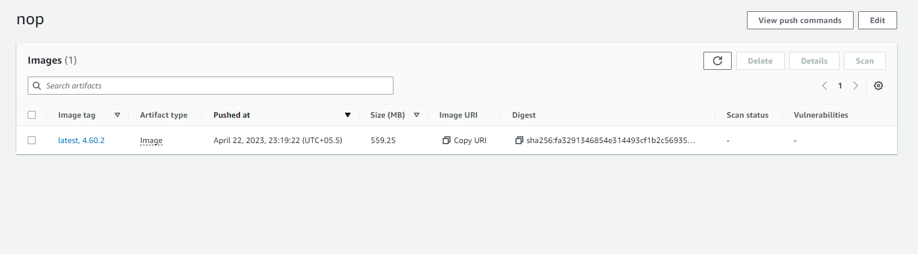

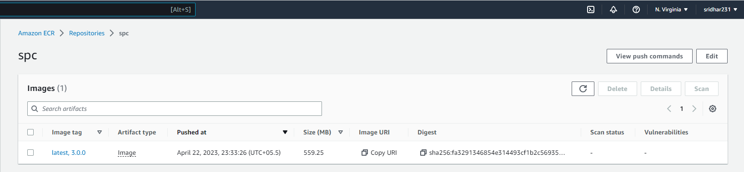

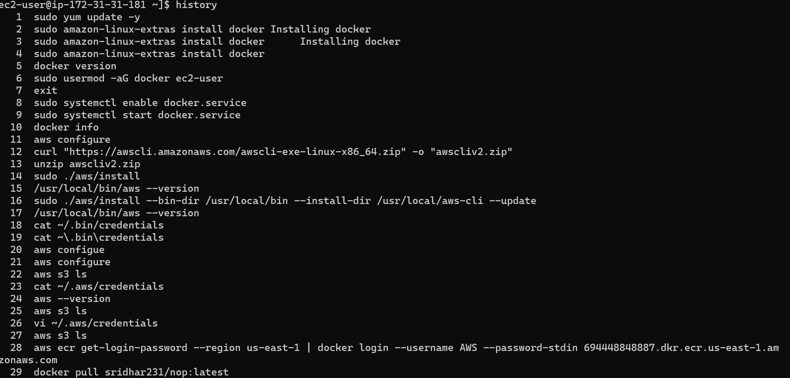

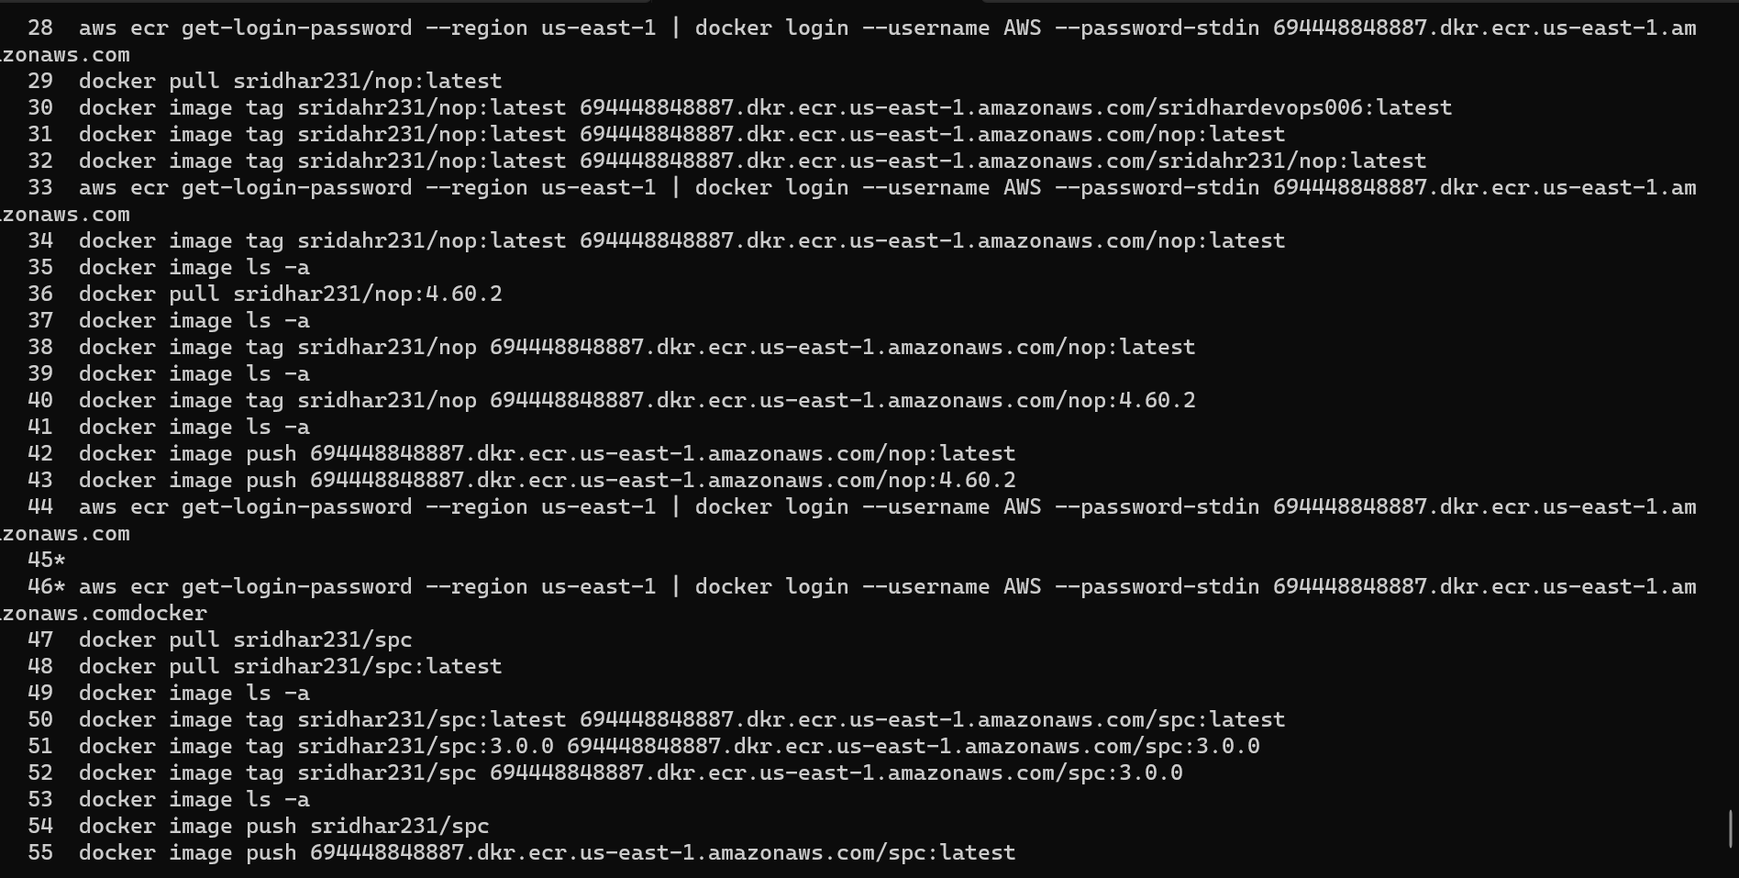

1. Azure ACR
2. Write a docker compose file for
3. Nop Commerce

1. Spring petclinic
2. Game of life
3. Student Courses Register

distributed system is a collection of independent components located on different machines that share messages with each other in order to achieve common goals

Node: a point in a network or diagram at which lines or pathways [intersect](https://www.google.com/search?rlz=1C1VDKB_enIN1053IN1053&sxsrf=APwXEdfzH1HrQ4P_aEfd24FpjuOk9J0h3Q:1682217624090&q=intersect&si=AMnBZoFEI0LGJdD1jElhAGFwRnmoUB8OoxPB9zTMt56e7UYORwCU_8B97QCdtVu_vM_IleuELx8rkh31LnMIewwk5kAHs2dNuQ%3D%3D&expnd=1) or branch.

A Kubernetes cluster is a set of nodes that run containerized applications

microservice is just a computer program which runs on a server or a virtual computing instance and responds to network requests.

A stateful app is a program that saves client data from the activities of one session for use in the next session. The data that is saved is called the application's state. Apps can be stateful or stateless.

What is a stateless application? A stateless app is an application program that does not save client data generated in one session for use in the next session with that client. Each session is carried out as if it was the first time and responses are not dependent upon data from a previous session.

A monolithic architecture is a singular, large computing network with one code base that couples all of the business concerns together